Invitation to dialogue conference:

How to innovate «moving around»

Ruter invites innovators, startups and suppliers of IT-systems and services to exchange ideas on how to collaborate on improving and innovating sustainable mobility.

When: 13 November 2018 - 09.00 - 13.00
Where: DOGA, Hausmannsgate 16, Oslo

Traditionally, Ruter has had their eyes fixed on how to provide «public transport».
Now we expand our view, and say that we are working towards a "sustainable freedom of movement”.
This means that Ruter will facilitate for our customers to get flexible transport-solutions for the whole journey “door-to-door”, travels that are safe, reliable, available and easy to use.
The offering will include traditional scheduled public transport combined with non-scheduled, shared or individual transport-solutions, in cooperation with public and private mobility providers.

Ruter currently works with many different suppliers and partners, but we have less experience working with, or procuring from, innovators and startup companies. We tend to ask for help with specific problems or a specific service or product.
Now, however, we see an increasing need for more dialogue around our challenges with both current and potential suppliers.

The objective of the conference is to establish a fruitful conversation with technology-suppliers, services-providers, innovators and startups that offer innovative products, solutions or ideas supporting Ruter’s vision.
Our goal is to implement one or more innovative procurement processes.

The purpose of this dialogue conference is:
- To strengthen our interaction with both startups and established suppliers, enabling them to use Ruter’s data and position in the market to develop solutions that meet our customer’s needs, and at the same time contributes to a more sustainable region.
- To strengthen Ruter’s understanding of how innovators, startups and established companies can help Ruter in our work towards a “sustainable freedom to move around”, and help us develop cooperation with all these types of players in ways that are mutually beneficial.

We will be presenting our ambitions in this area for the coming years and demonstrate Ruter’s digital platform – mainly from a “service” perspective, but also touching on architecture and technical implementation. We also want to share our vision for a “sustainable freedom of movement” and how we see its impact in the future.

Based on feedback and interest during the conference, we will initiate more specific processes in order to try to answer these questions:
- Combined mobility – how can we increase walking and biking and reduce the use of cars?
- Sustainable future – how can we utilize data from Ruter and others to measure our contribution to the UN Sustainable Development Goals, and how can this be used to improve our customer offering or accelerate the journey towards a sustainable low-emission future.

More information about the possibilities for one-to-one meetings with Ruter will be given during the dialogue conference.

PREPARATIONS AND REGISTRATION
Ruter wants to explore and discuss how to better collaborate with new partners. Therefore we want your feedback on what you would like to address at the conference. In particular we are interested in concrete proposals for activities and areas of collaboration.
Please submit your input by e-mail by November 11th, 2018 to anbud@ruter.no so that we can allocate time for companies that would like to share their perspectives. Ruter will compile the input into a presentation that may form the basis for discussions.

Each company may register two participants in the conference and registration is required. Companies sending feedback/questions/input will be prioritized.

All information exchanged, presented or discussed in the conference will be made publicly available through https://ruter.no/kollektivanbud/moter/.

Program:

09:00 | Welcome and opening | Terje Storhaug (CIO / Head of digital platforms and systems)
09:15 | Ruters ambitions with «sustainable freedom to move around».  Ongoing and planned activities within platform and service development.  Possible future needs in combined mobility and sustainability. | Bernt Reitan Jenssen (CEO)  Terje Storhaug, subject matter experts and product owners  Endre Angelvik (VP Mobility services) and  Frode Hvattum, (Head of strategy)
10:30 | Break
11:00 | Presentations from participants.  Discussions. | All
12:45 | Summary.
13:00 | End of conference.

For registrations, please complete the registration form by November 12th, 10:00 2018.

If you have questions at this stage – please send to anbud@ruter.no
Welcome!

BACKGROUND 1: EXTRACTS FROM RUTERS STRATEGIES

M2016
We are faced with a major change in how people move around, driven by innovation in technology and business models. The mobility market is in great turmoil and now a race for marked positions is taking place with significant investment in shared mobility solutions and automation of vehicles. New actors and business models challenge today's perceptions of how we move.

Ruter's response is to search for opportunities to improve the customer experience and to enable the population in our area to move freely around in a sustainable way. Ruter wants to be an effective tool in ensuring that the future mobility solutions will be the right ones for society as a whole. To be that tool, we must understand the needs of our customers and meet these with personalized services. If we manage to deliver on this, the inhabitants will prefer us as their supplier and they will trust that we manage their data for the benefit of them and society.

Every four years, Ruter puts forward a strategy for public transport. The current strategy M2016 was launched in the autumn of 2015 and the next strategy M2020 will be launched in 2019. M2016 is the document that points to long-term development for public transport. In M2016 we lifted our view from public transport into mobility solutions to ensure the development of an increasingly attractive offer for the region's residents. In this, we recognize that a public transport company such as Ruter, with partners and operators, should take a broader grip on mobility challenges.

Ruter and sustainable development
Public transport has major impact on many sustainability dimensions:
- A well-functioning society with high quality of life constitutes an attractive region. Good mobility gives freedom of movement and is essential for the community to function well and for the region to be regarded as attractive.
- Good mobility solutions help to reduce inequality so that the individual has the practical and economic opportunity to participate in working life and education, as well as to unfold themselves in their spare time.
- Effective mobility is about good land management as a scarce asset in urban areas. It is a prerequisite for business development and economic prosperity.
- Good mobility solutions are critical to reducing environmental impact from the transport sector, thus contributing to better health in the population.
The sum is a more sustainable and attractive region for current and future residents.

Ruter's contribution to society will change in the future, because major investments and phasing-in of new technology will lead to major changes in the mobility market. We expect increasing competition and an ecosystem with actors and business models in continuous development. It is important that Ruter understands the challenges and exploits the opportunities that increased digitalization and new mobility actors bring. We do that best by understanding and delivering even better customer needs than we do today. Being relevant to the customers is necessary for us a public transport authority. Where private actors have as main goal of maximizing economic performance, Ruter aims to maximize social, economic and environmental benefits. Ruter's ability to contribute to value creation for our society is our most important differentiator.

Ruter have chosen to use the UN's sustainable development goals as a framework to understand and strengthen our position. Ruter has a special focus on Objective 11 'Sustainable Cities and Society' - which is based on Ruter's vision for sustainable freedom to movement. This has a clear effect on both individuals and the whole community through Objective 3 'Good Health and well being', Goal 10 'Reduced Inequality', Goal 8 'Decent Work and Economic Growth' and Goal 13 'Climate action'. The way Ruter reaches these goals is through using measures contained in Objective 9 'Industry, innovation and Infrastructure', Goal 12 'Responsible Consumption and Production' and Goal 17 Partnership for the goals

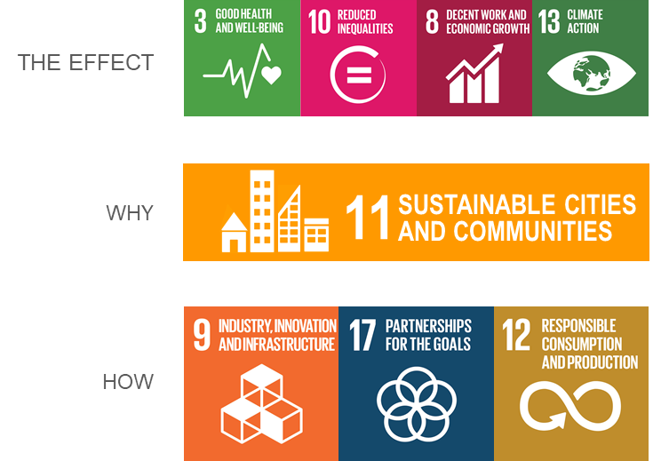

Our focus on UN’s development goals will strengthen Ruter's ability to reach political goals in the future. In addition, Ruter can strengthen its role as an attractive partner to private actors and help their innovation capabilities and resources also support long-term goals, in line with Oslo and Akershus's vision and goals.

BACKGROUND 2: ABOUT RUTERS FUTURE DIGITAL PLATFORM

Ruter’s IT portfolio is composed of several independent and proprietary solutions mainly supporting a specific function or customer channel. The systems are monolithic and depends heavily on distributed hardware and distributed processing capabilities. Due to this, the solutions are costly to operate and maintain – and they are not suited as platforms for developing the dynamic and integrated services that will be required in the future. In addition – some solutions will reach “end-of-life” this decade and our goal is the avoid having to re-invest in similar solutions. As a consequence, Ruter defined in 2016 the architecture of a completely new digital platform that is cloud-based, data-centric, event-driven and is designed for processing huge amounts of data in real-time. It is based on technologies developed by large international corporations for their own use, but later made available as Open Source. The development of the platform itself as well as the services takes place in multifunctional teams using principles from Design Sprint, Lean, Agile, DevOps and CI/CD. The platform is already in production hosting some new services.

Ruter is a member of ITxPT (see www.itxpt.org) and is strongly supporting the development of standardized solutions as it has some significant advantages above proprietary ones. Through standards, the market opens, and they contribute to fostering innovations, shortening time-to-market for new services and reducing cost-of-ownership. During the next few years, several large operator contracts will be renewed and a large number of new vehicles (busses, trams and ferries) will be replaced. Ruter specifies implementation of the ITxPT-specification as mandatory. The operators are fully responsible also for the IT-equipment ao-board the vehicles. The new contracts specify several data streams that the operator is responsible for producing by means of the on-board equipment, various sensors and registers. The data shall be transmitted in real-time to Ruter’s Digital Platform where the data will be processed, combined with other data streams, stored and published for consummation in various channels. Data streams include vehicle position, passenger load and movements (embark/disembark) and various vehicle-related data (e.g. speed, friction, fuel consumption). Ruter is in process of defining policies for data management – including which data to make available and the associated terms and conditions for such access.

The majority of the population in our region is already using several digital services. As a fact – more that 95 % of all passengers on board our vehicles have a smart phone. The expectation and demand for personalized services is increasing. Access to data from vehicles, road-authorities, weather forecasts and similar – in addition to data from de travelers, will make possible the development of services that are personal, contextual and in real-time.

